AIJA CONFERENCE
Rome, 24 October 2013

HOTEL BOOKING FORM
To be sent directly to the hotel

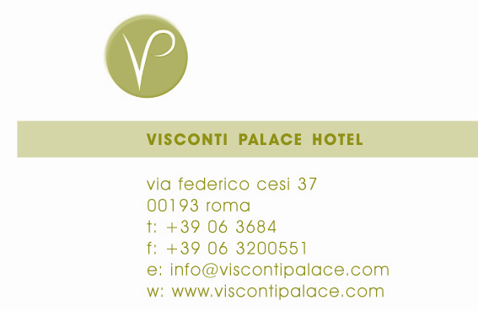
Reservations Department
Via Federico Cesi, 37
I-00193 Roma
Reservation office Tel. +39-06-3684847 – fax +39-06-3684844
E-mail: mice@viscontipalace.com

IMPORTANT
Please make your reservation directly with the hotel Mice Department by sending this form via fax or e-mail. Full details of credit card are required along with this form in order to guarantee/secure the reservation. The cancellation policy is 48 hours prior to the arrival.

Name ____________________________________________________

Address ____________________________________________________

Telephone no. _________________________ Fax no.____________________

Email address ____________________________________________________

Name of accomp. person ____________________________________________________

¦ Superior room Single use at € 180,00 / per room per night, Buffet breakfast and Vat included
¦ Superior double room at € 210,00 / per room per night, Buffet breakfast and Vat included

The Rome City tax Equal to Euro 3,00 per person, daily is NOT included

Arrival on: Departure on:

PAYMENT INFORMATION
I guarantee my arrival and the payment of my account at the Hotel with the following credit card:

Credit Card: American Express Diners Club Master Card VISA

Credit Card Number Expiration Date

Name of Credit Card Holder
HOTEL CONFIRMATION
We are pleased to confirm your reservation:

Confirmation No.: _____________________ Signature: _____________________

Hotel Stamp:

